Name ____________________________

Cohort ___________________________

Date _____________________________

Silent College Talk

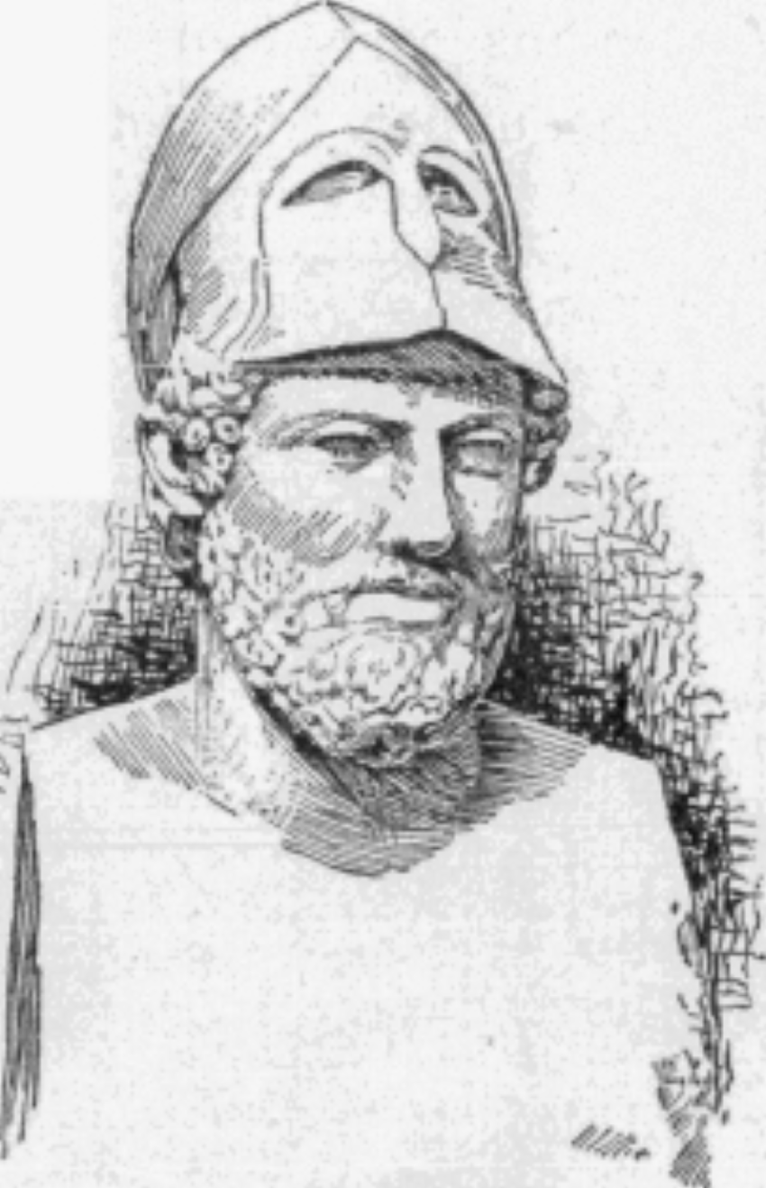 | Pericles of Athens says:  “Democracy is the fairest form of government.”
Name:

Name:

Name:

Summary
Summary must include key points from each opinion and your final thought on the topic.
Name:

Agreement Starters |  | Disagreement Starters
-I agree because…  -I think so because…  -This person has a point because…  -I also see it that way because… |  | -I disagree because…  -I don’t agree with…because…  -I see it differently because…  -My point of view is different because…
Summary Starters
-My group believes…

-Overall my peers believe…

-The summary of my classmates goes as follows…

-To sum up the views of my peers…

