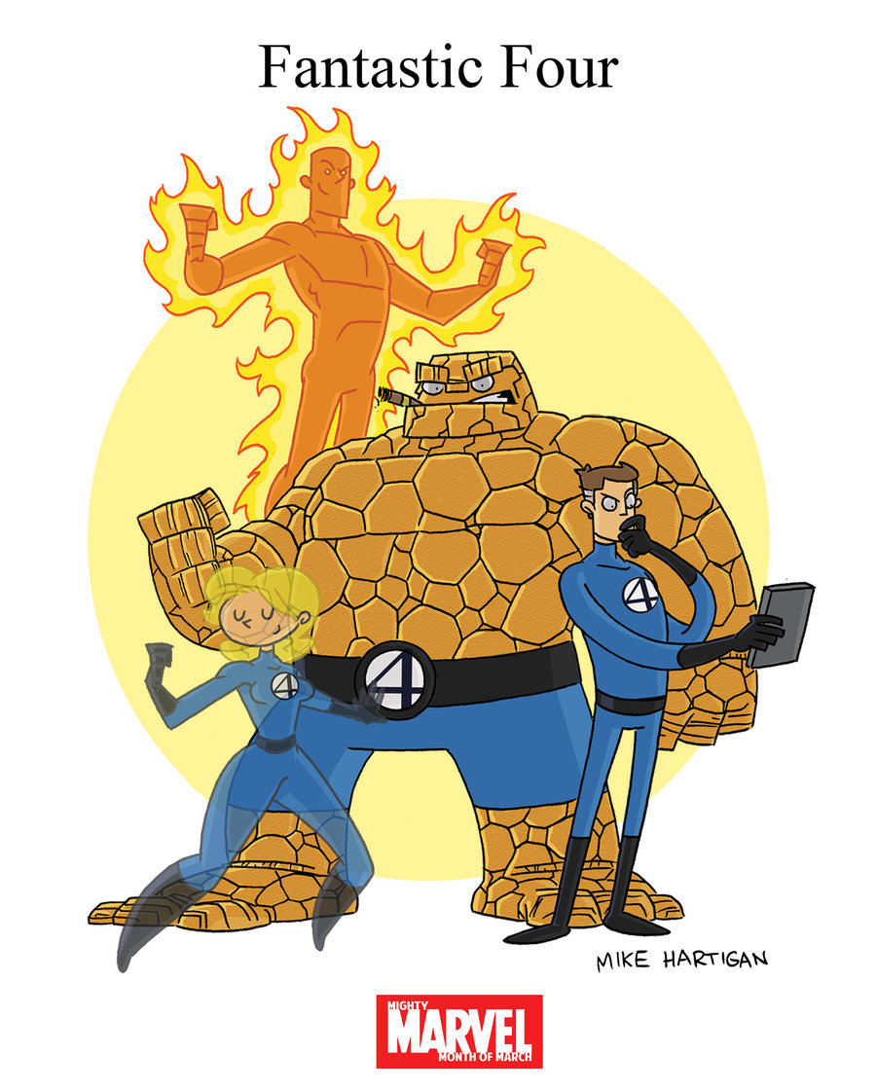
The Fantastic Four Easy to use
Discussion Strategies

1. Rank and Sort  Objective: to rank important words or ideas.  Why? The ranking or sorting of ideas promotes metacognition and stimulates discussion by having students justify their thoughts.  How to play?  1. Pose a debatable question or ask students to construct a category.  2. Students could work individually, in pairs, or in table groups.  3. Students then justify their ranking or sorting.  Example: Rank the following presidents in order of importance. Be prepared to justify.  Which of these presidents would be best at leading the country today? | 2. Divided Line  Objective: Have students discuss or debate a problem or a controversial question.  Why? It allows students to hear from peers with similar and different views. In addition it teaches students to justify their position.  How to play?  1. Pose a debatable question.  2. Have students reflect silently by writing about question  3. Have students pick a side of the room either for agreement or disagreement.  4. Have students share with a partner who agrees with his or her view.  5. Opposing groups then share and justify their opinions.  Example: Do you believe Thomas Jefferson was a hypocrite for writing The Declaration of Independence while being a slave owner?
3. Appointment Clocks  Objective: to meet with various peers and discuss ideas after a reading.  Why? It provides opportunities for students to process information several times and helps to uncover misconceptions, reinforce learning of a concept.  How to play?  1. Have students select one appointment at a time.  2. Have students discuss 1 debatable question or several with each appointment. Could also be used strategically as a “check for understanding or in conjunction with leveled questions or text dependant questions.  Example: Share with your 12:00 appointment who you believe is the greatest American president and why? | 4. Four Corners  Objective: Use your room environment as a check for understanding or to justify a position.  Why: It allows the teacher to use the environment as a tool to check for understanding or to help students justify their thoughts with each other before discussing with whole class or teacher.  How to play?  1.Provide a debatable question with preselected stances. A corner of the room represents each stance. Or provide a rating or level of understanding for each corner of the room.  2. Give students time for written reflection prior to selecting stance.  3. Have students justify stance.  Example: Between George Washington, Thomas Jefferson, Abraham Lincoln, and Theodore Roosevelt who do you believe was the most influential to American politics? Please justify.  Or please rate your knowledge of George Washington from 4 being best to 1 being lowest and explain why.

Thomas Jefferson
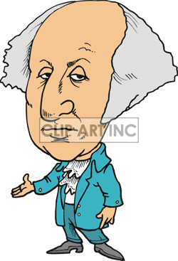
George Washington

Abraham Lincoln
Theodore Roosevelt

